Capital words:

%{

#include<stdio.h>

%}

%%

[A-Z]+[\t\n ] { printf("%s",yytext); }

. ;

%%

Int yywrap(){}

int main( )

{

printf("Enter the input string:\n");

yylex();

}

%{

%}

%%

[a-z.0-9_]+@[a-z]+".com"|".in" { printf(“it is valid”);}

.+ { printf(“it is not valid”);}

%%

int yywrap(){}

int main()

{

printf("enter the mail:");

yylex();

} %{

%}

%%

[6-9][0-9]{9} {printf("\n mobile number valid\n");}

.+ {printf("\n mobile number invalid\n");}

%%

int yywrap(void){}

int main()

{

printf("\n enter the mobile number:");

yylex();

printf("\n");

return 0;

}

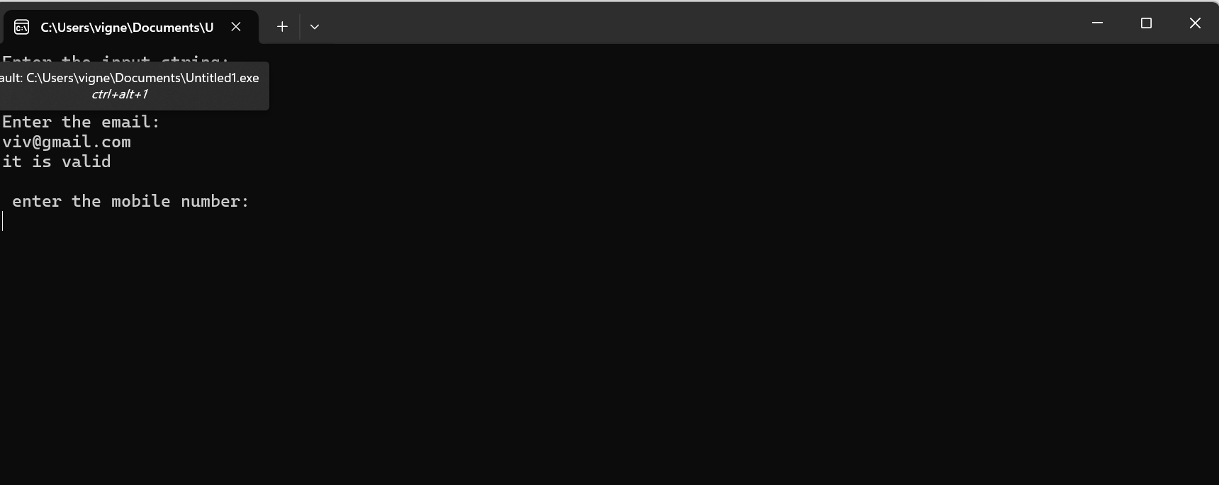

Mobile number:

%{

%}

%%

[6-9][0-9]{9} {printf("\n mobile number valid\n");}

.+ {printf("\n mobile number invalid\n");}

%%

int yywrap(void){}

int main()

{

printf("\n enter the mobile number:");

yylex();

printf("\n");

return 0;

}

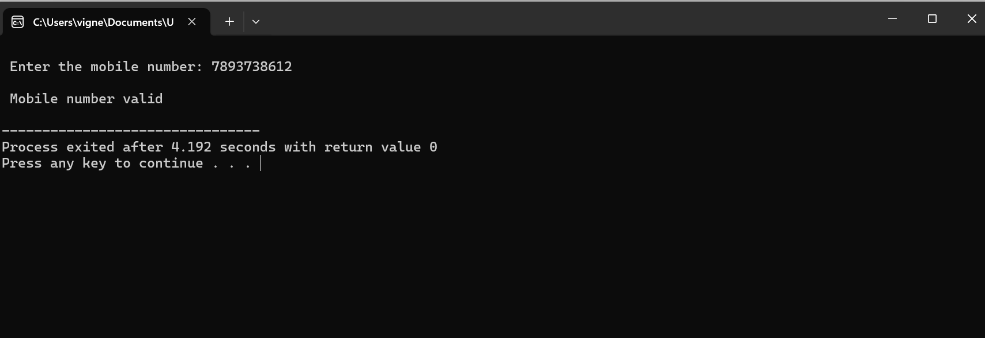

#include <stdio.h>

#include <stdlib.h>

#include <string.h>

int count_comments(FILE *file) {

int nc = 0;

char line[1024];

while (fgets(line, sizeof(line), file)) {

if (strncmp(line, "//", 2) == 0) {

nc++;

} else if (strncmp(line, "/*", 2) == 0) {

nc++;

while (fgets(line, sizeof(line), file)) {

if (strstr(line, "*/")) break;

}

}

}

return nc;

}

int main(int argc, char *argv[]) {

if (argc < 2) {

printf("Usage: %s <filename>\n", argv[0]);

return 1;

}

FILE *file = fopen(argv[1], "r");

if (!file) {

printf("Error opening file: %s\n", argv[1]);

return 1;

}

int nc = count_comments(file);

fclose(file);

printf("The number of comment lines = %d\n", nc);

return 0;

}